

**MATHEMATICS  
Methods Units 1 & 2**

**Test 3 – Functions, Transformations and Relations**

**Chapters 8 and 9**

**Semester 1 2019**

# 

**Section Two - Calculator Assumed**

Time allowed for this section

Working time for this section: 30 minutes

Marks available: 35 marks

## Material required/recommended for this section

##### To be provided by the supervisor

This Question/Answer booklet

Formula sheet

##### To be provided by the candidate

Standard items: pens, pencils, pencil sharpener, eraser, correction fluid, ruler, highlighters

Special items: drawing instruments, templates, notes on one unfolded sheet of A4 paper, and up to three calculators satisfying the conditions set by the Curriculum Council for this course.

## Important note to candidates

No other items may be used in this section of the examination. It is **your** responsibility to ensure that you do not have any unauthorised notes or other items of a non-personal nature in the examination room. If you have any unauthorised material with you, hand it to the supervisor **before** reading any further.

1. (9 marks)

Consider the function for

1. On the axes provided below, sketch the graph of **within the specified domain**. [3]



1. State the range for for the domain specified. Give your answers correct to one decimal place. [2]
2. State the coordinates of the horizontal intercept(s) of for the domain specified. [2]
3. State the coordinates of the turning point(s) of for the domain specified. State the nature of this point. Give your answer correct to one decimal place. [2]
4. (8 marks)

Describe a series of transformations required to convert into *.*

1. and [2]
2. and [2]
3. and [2]
4. and [2]
5. (9 marks)

Consider the three graphs shown below.

1. State whether each is a relation or a function. [3]
2. Show justification with an appropriate test. [3]
3. Describe the graph using one of the terms one-to-one, one-to-many, many-to-one. [3]

Graph A Graph B Graph C

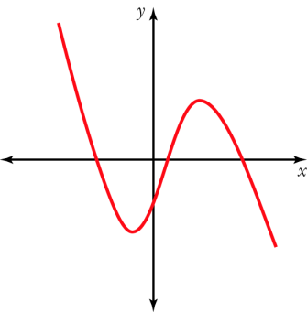 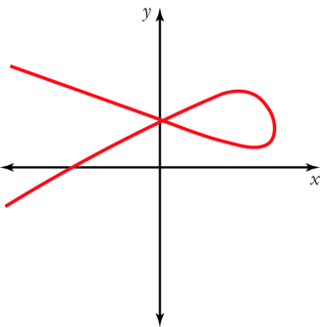 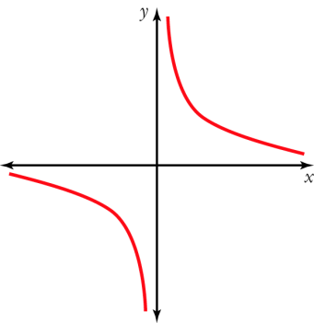

1. (9 marks)

Given that , and

1. [1]
2. [1]
3. [1]
4. [2]
5. [2]
6. [2]

**End of Test**